Connect, Control and Monitor with IDP's Controllers and IDP's Android solutions
IDP presents a highly configurable and affordable automation platform controlled by Android mobile devices.
The devices are based on Tibbo Technology and enables extension with micro modules. These products provide high processing power with built-in Ethernet networking and Internet capabilities.

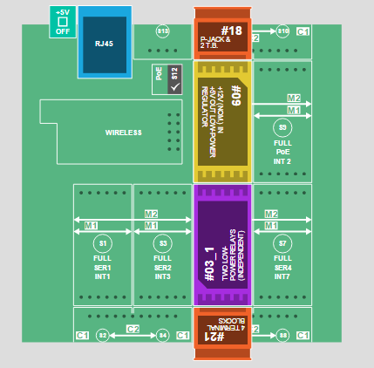
Picture 1

IDP's Smart Home/Industry Controller lets you control almost any electric device. Simply connect the internal relay to switch your devices ( Air Conditioners, lightning, water pumps, etc.)
Your mobile device can control unlimited number of controllers. All in one Android application. You can control and read the status of your devices at any time.
Communication with the controller can be either by IP line, WiFi (both supported internally by the controller) or by cellular by connecting an external cellular modem.

Application description

Switch to Relays Screen

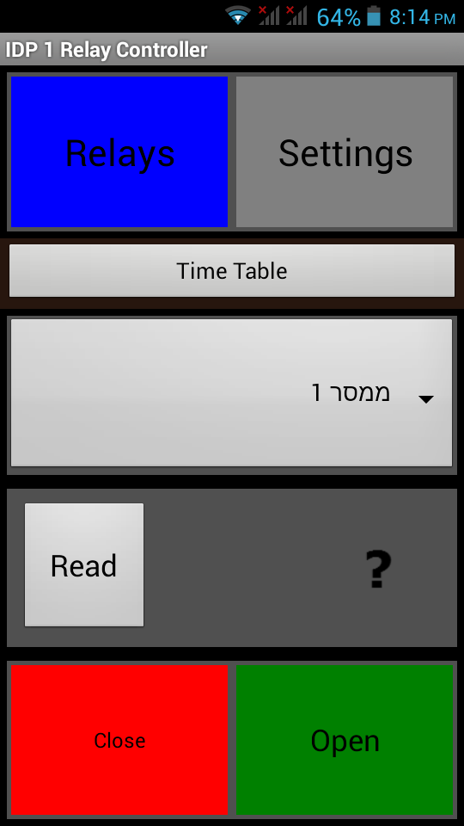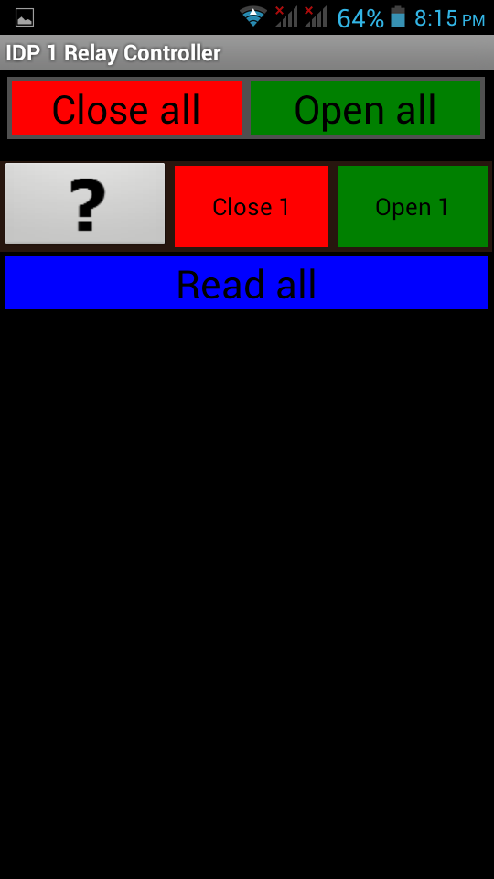
Main Screen
Relays Screen

How to set up your controller with IDP android application
- Download Tibbo program and program your TPS2 controller as described in picture 1 and set up the IP address and PORT with the appropriate setting (i.e. DS manager).
- Download the Android application and install into your Android smartphone
- Run the application
- The first time you run the application, the Settings screen will be opened automatically.
- Write the IP address of your controller and the PORT number into the appropriate entries as below picture
- Press the “Send request to IDP” button. This will open a mail that you will need to press send.
- Answer from IDP server will be available within 24 hours. Upon receiving IDP answer, you will be able to activate the Android application by pressing the “Sync with IDP server” button.
- If you received a message that synchronization was done, you will be able to control your TPS2 controller with the Android application anywhere and anytime.
- For any questions, IDP support team will be happy to assist.

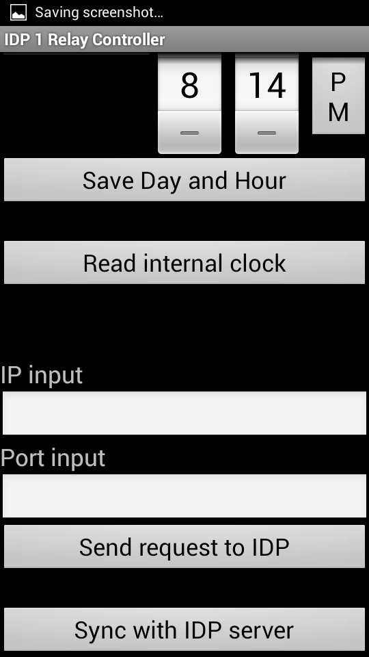
Enter your IP address
Enter your PORT number

